Date : 09.11.2024

Name: Samyuktha V

Department: Information Technology

DSA Practice 1

Coding practice Problems

1. Maximum Subarray Sum – Kadane‟s Algorithm:

Given an array arr[], the task is to find the subarray that has the maximum sum and return its sum.

Input: arr[] = {2, 3, -8, 7, -1, 2, 3}

Output: 11

Explanation: The subarray {7, -1, 2, 3} has the largest sum 11.

Solution:

import java.util.Scanner;

public class Demo{

    public static void main(String[] args) {

        Scanner sc=new Scanner(System.in);

        System.out.print("Enter the size of array: ");

        int n=sc.nextInt();

        System.out.println("Enter the array elements: ");

        int[] arr=new int[n];

        for(int i=0;i<n;i++) arr[i]=sc.nextInt();

        sc.close();

        int global=Integer.MIN_VALUE;

        int local=0;

        for (int i : arr) {

            local+=i;

            if (local>global) global=local;

            if (local<0) local=0;

        }

        System.out.println("The Maximum Subarray Sum is "+global);

    }

}

Output:

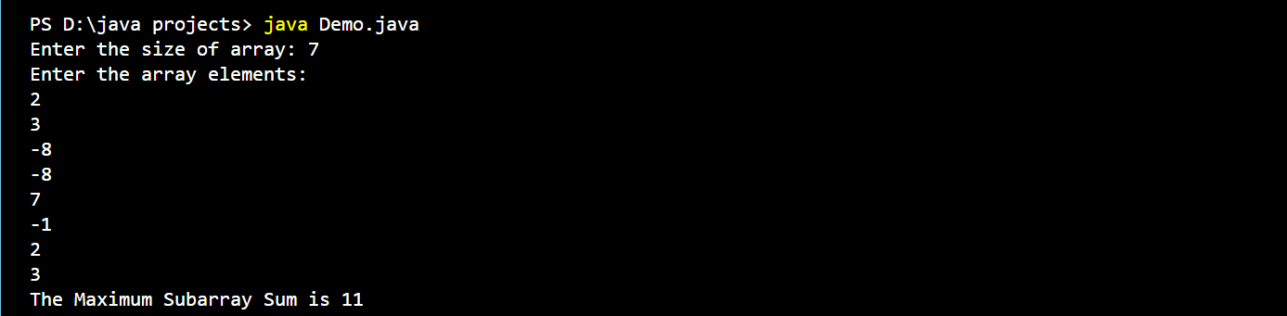

Time Complexity: O(n)

Space Complexity: O(1)

1. Maximum Product Subarray

Given an integer array, the task is to find the maximum product of any subarray.

Input: arr[] = {-2, 6, -3, -10, 0, 2}

Output: 180

Explanation: The subarray with maximum product is {6, -3, -10} with product = 6 * (-3) * (-10) = 180

Input: arr[] = {-1, -3, -10, 0, 60}

Output: 60

Explanation: The subarray with maximum product is {60}.

Solution:

import java.util.Scanner;

public class MaximumProductSubarray {

    public static void main(String[] args) {

        Scanner sc=new Scanner(System.in);

        System.out.print("Enter the size of array: ");

        int n=sc.nextInt();

        System.out.println("Enter the array elements: ");

        int[] arr=new int[n];

        for(int i=0;i<n;i++) arr[i]=sc.nextInt();

        sc.close();

        int prefix=1;

        int suffix=1;

        int ans=Integer.MIN_VALUE;

        for(int i=0;i<n;i++){

            prefix*=arr[i];

            suffix*=arr[n-1-i];

            ans=Math.max(ans,Math.max(prefix,suffix));

            if (prefix==0) prefix=1;

            if (suffix==0) suffix=1;

        }

        System.out.println("The Maximum Subarray Product is "+ ans);

    }

}

Output:

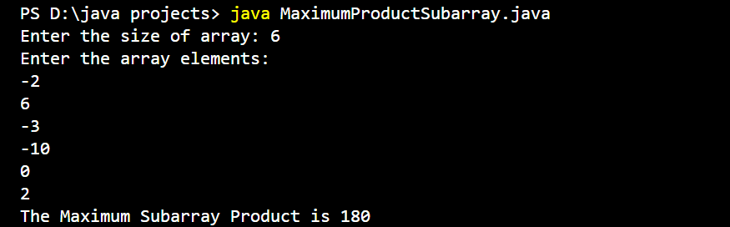

Time Complexity: O(n)

Space Complexity: O(1)

1. Search in a sorted and rotated Array

Given a sorted and rotated array arr[] of n distinct elements, the task is to find the index of given key in the array. If the key is not present in the array, return -1.

Input : arr[] = {4, 5, 6, 7, 0, 1, 2}, key = 0

Output : 4

Input : arr[] = { 4, 5, 6, 7, 0, 1, 2 }, key = 3

Output : -1

Input : arr[] = {50, 10, 20, 30, 40}, key = 10

Output : 1

Solution:

import java.util.Scanner;

public class BinarySearch {

    public static void main(String[] args) {

        Scanner sc=new Scanner(System.in);

        System.out.print("Enter the size of array: ");

        int n=sc.nextInt();

        System.out.println("Enter the array elements: ");

        int[] arr=new int[n];

        for(int i=0;i<n;i++) arr[i]=sc.nextInt();

        System.out.print("Enter the key to search: ");

        int key=sc.nextInt();

        sc.close();

        int start=0;

        int end=n-1;

        int middle;

        int ans=-1;

        while(start<=end){

            middle=(start+end)/2;

            if (arr[middle]==key){

                ans=middle;

                break;

            }

            else if (arr[start]<=arr[middle]){

                if(arr[start]<=key && arr[middle]>key) end=middle-1;

                else start=middle+1;

            }

            else{

                if (arr[middle+1]<=key && arr[end]>=key) start=middle+1;

                else end=middle-1;

            }

        }

        System.out.println("Index of key is: "+ans);

    }

}

Output:

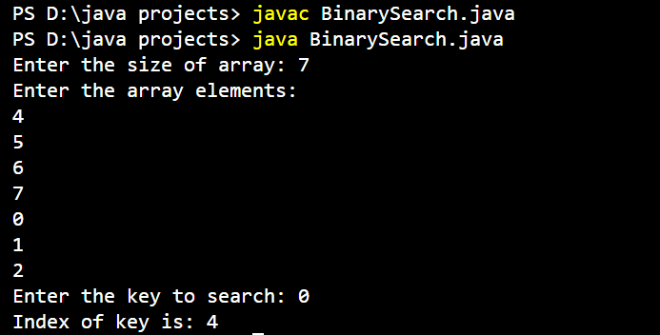

Time Complexity: O(log n)

Space Complexity: O(1)

1. Container with Most Water

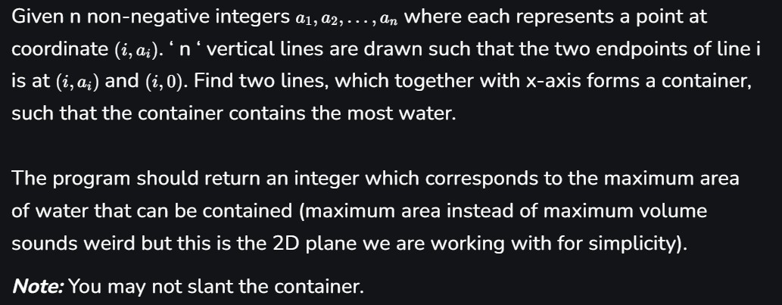

Input: arr = [1, 5, 4, 3]

Output: 6

Explanation: 5 and 3 are distance 2 apart. So the size of the base = 2.

Height of container = min(5, 3) = 3.

So total area = 3 * 2 = 6

Input: arr = [3, 1, 2, 4, 5]

Output: 12

Explanation: 5 and 3 are distance 4 apart. So the size of the base = 4.

Height of container = min(5, 3) = 3. So total area = 4 * 3 = 12.

Solution:

import java.util.Scanner;

public class ContainerWithMostWater {

    public static void main(String[] args) {

        Scanner sc=new Scanner(System.in);

        System.out.print("Enter the size of array: ");

        int n=sc.nextInt();

        System.out.println("Enter the array elements: ");

        int[] arr=new int[n];

        for(int i=0;i<n;i++) arr[i]=sc.nextInt();

        sc.close();

        System.out.println("Maximum Storage of Tank is "+ MaxStorage(arr));

    }

    private static int MaxStorage(int[] arr){

        int n=arr.length;

        int left=0,right=n-1;

        int capacity=0;

        while(left<right){

            capacity=Math.max(capacity,(right-left)*Math.min(arr[left],arr[right]));

            if (arr[left]<arr[right]) left++;

            else right--;

        }

        return capacity;

    }

}

Output:

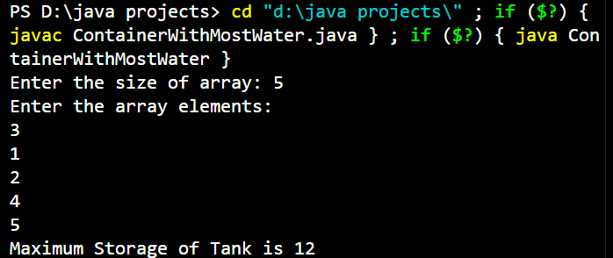

Time Complexity: O(n)

Space Complexity: O(1)

1. Find the Factorial of a large number

Input: 100

Output: 933262154439441526816992388562667004907159682643816214685929638952175999932299156089414639761565182862536979208272237582511852109168640000000000000000000000 00

Input: 50

Output: 30414093201713378043612608166064768844377641568960512000000000000

Solution:

import java.math.BigInteger;

import java.util.Scanner;

public class FactorialOfLargeNumber {

    public static void main(String[] args) {

        Scanner sc=new Scanner(System.in);

        System.out.print("Enter the number to find factorial: ");

        int n=sc.nextInt();

        sc.close();

        BigInteger ans=BigInteger.ONE;

        for (int i=1;i<=n;i++) ans=ans.multiply(BigInteger.valueOf(i));

        System.out.println("The factorial of "+n+" is "+ans);

    }

}

Output:

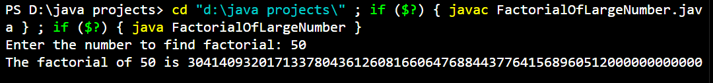

Time Complexity: O(n)

Space Complexity: O(1)

1. Trapping Rainwater Problem

It states that given an array of n non-negative integers arr[] representing an elevation map where the width of each bar is 1, compute how much water it can trap after rain.

Input: arr[] = {3, 0, 1, 0, 4, 0, 2}

Output: 10

Explanation: The expected rainwater to be trapped is shown in the above image. Input: arr[] = {3, 0, 2, 0, 4}

Output: 7

Explanation: We trap 0 + 3 + 1 + 3 + 0 = 7 units.

Input: arr[] = {1, 2, 3, 4}

Output: 0

Explanation : We cannot trap water as there is no height bound on both sides

Input: arr[] = {10, 9, 0, 5}

Output: 5

Explanation : We trap 0 + 0 + 5 + 0 = 5

Solution:

import java.util.Scanner;

public class TrappingRainWater {

    public static void main(String[] args) {

        Scanner sc=new Scanner(System.in);

        System.out.print("Enter the size of array: ");

        int n=sc.nextInt();

        System.out.println("Enter the array elements: ");

        int[] height=new int[n];

        for(int i=0;i<n;i++) height[i]=sc.nextInt();

        sc.close();

        int left=0,right=n-1;

        int leftmax=height[0],rightmax=height[n-1];

        int water=0;

        while(left<right){

            if(leftmax<rightmax){

                left++;

                leftmax=Math.max(leftmax,height[left]);

                water+=leftmax-height[left];

            }

            else{

                right--;

                rightmax=Math.max(rightmax,height[right]);

                water+=rightmax-height[right];

            }

        }

        System.out.println("Amount of water trapped is "+water);

    }

}

Output:

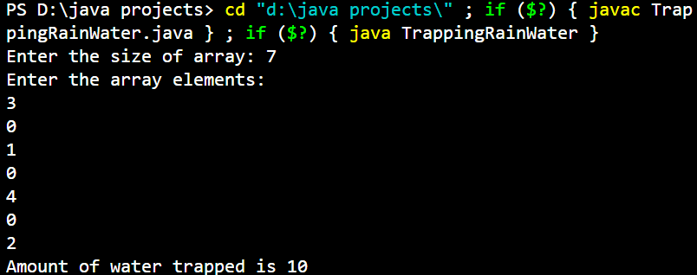

Time Complexity: O(n)

Space Complexity: O(1)

1. Chocolate Distribution Problem

Given an array arr[] of n integers where arr[i] represents the number of chocolates in ith packet. Each packet can have a variable number of chocolates. There are m students, the task is to distribute chocolate packets such that: Each student gets exactly one packet. The difference between the maximum and minimum number of chocolates in the packets given to the students is minimized.

Input: arr[] = {7, 3, 2, 4, 9, 12, 56}, m = 3

Output: 2

Explanation: If we distribute chocolate packets {3, 2, 4}, we will get the minimum difference, that is 2.

Input: arr[] = {7, 3, 2, 4, 9, 12, 56}, m = 5

Output: 7

Explanation: If we distribute chocolate packets {3, 2, 4, 9, 7}, we will get the minimum difference, that is 9 – 2 = 7.

Solution:

import java.util.*;

public class ChocolateDistribution {

    public static void main(String[] args) {

        Scanner sc=new Scanner(System.in);

        System.out.print("Enter the number of packets of chocolates: ");

        int n=sc.nextInt();

        System.out.println("Enter the no. of chocolates in each packet: ");

        int[] arr=new int[n];

        for(int i=0;i<n;i++) arr[i]=sc.nextInt();

        System.out.print("Enter the number of students: ");

        int m=sc.nextInt();

        sc.close();

        Arrays.sort(arr);

        int min=arr[m-1]-arr[0];

        for (int i=0;i<=n-m;i++){

            min=Math.min(min,(arr[i+m-1]-arr[i]));

        }

        System.out.println("Minimum Difference is "+min);

    }

}

Output:

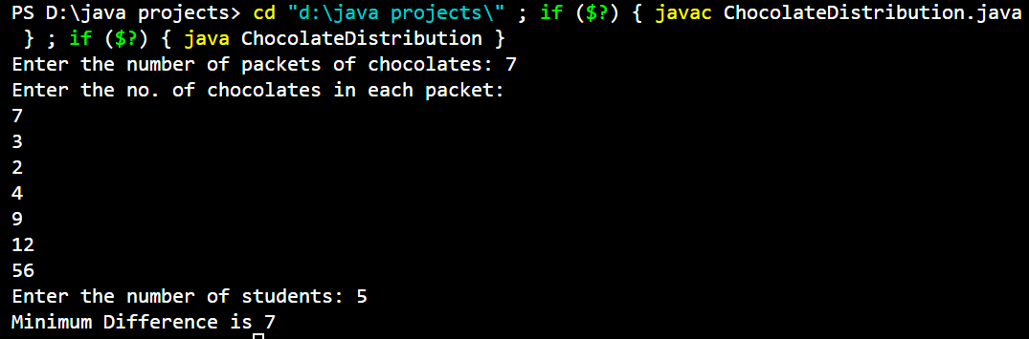

Time Complexity: O(n)

Space Complexity: O(1)

1. Merge Overlapping Intervals

Given an array of time intervals where arr[i] = [starti, endi], the task is to merge all the overlapping intervals into one and output the result which should have only mutually exclusive intervals.

Input: arr[] = [[1, 3], [2, 4], [6, 8], [9, 10]]

Output: [[1, 4], [6, 8], [9, 10]]

Explanation: In the given intervals, we have only two overlapping intervals [1, 3] and [2, 4]. Therefore, we will merge these two and return [[1, 4}], [6, 8], [9, 10]].

Input: arr[] = [[7, 8], [1, 5], [2, 4], [4, 6]]

Output: [[1, 6], [7, 8]]

Explanation: We will merge the overlapping intervals [[1, 5], [2, 4], [4, 6]] into a single interval [1, 6].

Solution:

import java.util.*;

public class MergeOverlappingIntervals {

    public static void main(String[] args) {

        Scanner sc=new Scanner(System.in);

        System.out.print("Enter the size of array: ");

        int n=sc.nextInt();

        System.out.println("Enter the intervals: ");

        int[][] interval=new int[n][2];

        for(int i=0;i<n;i++){

            interval[i][0]=sc.nextInt();

            interval[i][1]=sc.nextInt();

        }

        sc.close();

        Arrays.sort(interval,Comparator.comparingInt(a->a[0]));

        Stack<int[]> stack=new Stack<>();

        stack.push(new int[]{interval[0][0],interval[0][1]});

        for(int i=1;i<n;i++){

            int[] top=stack.peek();

            if(interval[i][0]<=top[1]){

                int[] newtop=new int[]{top[0],Math.max(top[1],interval[i][1])};

                stack.pop();

                stack.push(newtop);

            }

            else stack.push(new int[]{interval[i][0],interval[i][1]});

        }

        int[][] merged=stack.toArray(new int[stack.size()][]);

        System.out.println("The merged array is "+ Arrays.deepToString(merged));

    }

}

Output:

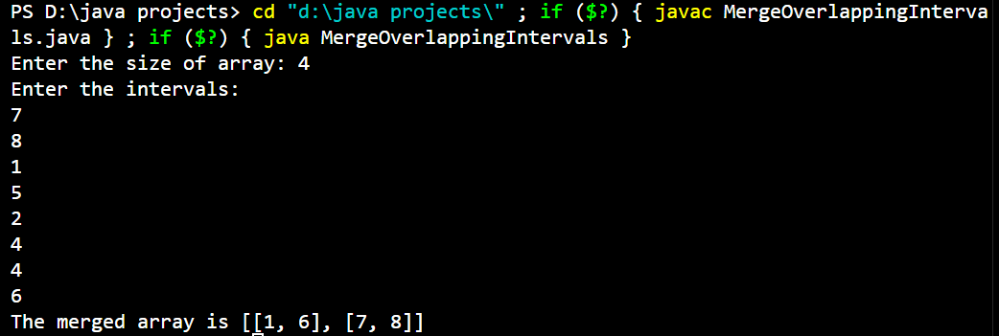

Time Complexity: O(nlogn)

Space Complexity: O(n)

1. A Boolean Matrix Question

Given a boolean matrix mat[M][N] of size M X N, modify it such that if a matrix cell mat[i][j] is 1 (or true) then make all the cells of ith row and jth column as 1.

Input: {{1, 0},

{0, 0}}

Output: {{1, 1}

{1, 0}}

Input: {{0, 0, 0},

{0, 0, 1}}

Output: {{0, 0, 1},

{1, 1, 1}}

Input: {{1, 0, 0, 1},

{0, 0, 1, 0},

{0, 0, 0, 0}}

Output: {{1, 1, 1, 1},

{1, 1, 1, 1},

{1, 0, 1, 1}}

Solution:

import java.util.*;

public class Main {

  public static void modifyMatrix(int[][] mat) {

        int M = mat.length;

        int N = mat[0].length;

        boolean[] rows = new boolean[M];

        boolean[] cols = new boolean[N];

        for (int i = 0; i < M; i++) {

            for (int j = 0; j < N; j++) {

                if (mat[i][j] == 1) {

                    rows[i] = true;

                    cols[j] = true;

                }

            }

        }

        for (int i = 0; i < M; i++) {

            for (int j = 0; j < N; j++) {

                if (rows[i] || cols[j]) {

                    mat[i][j] = 1;

                }

            }

        }

        for (int[] row : mat) {

            System.out.println(Arrays.toString(row));

        }

    }

    public static void main(String[] args) {

        Scanner sc = new Scanner(System.in);

        System.out.print("Enter number of rows: ");

        int M = sc.nextInt();

        System.out.print("Enter number of columns: ");

        int N = sc.nextInt();

        int[][] mat = new int[M][N];

        System.out.println("Enter elements:");

        for (int i = 0; i < M; i++) {

            for (int j = 0; j < N; j++) {

                mat[i][j] = sc.nextInt();

            }

        }

        modifyMatrix(mat);

        sc.close();

    }

}

Output:

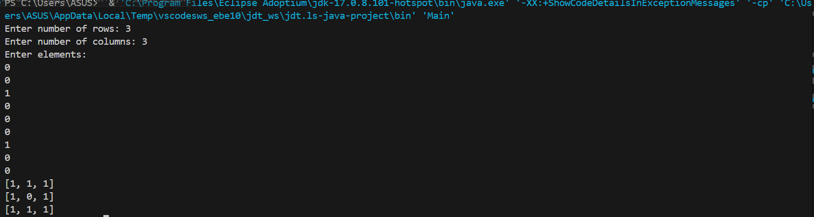

Time complexity :O(N*M)

Space Complexity :O(M + N).

1. Print a given matrix in spiral form

Given an m x n matrix, the task is to print all elements of the matrix in spiral form. Input: matrix = {{1, 2, 3, 4},

{5, 6, 7, 8},

{9, 10, 11, 12},

{13, 14, 15, 16 }}

Output: 1 2 3 4 8 12 16 15 14 13 9 5 6 7 11 10

Input: matrix = { {1, 2, 3, 4, 5, 6},

{7, 8, 9, 10, 11, 12},

{13, 14, 15, 16, 17, 18}}

Output: 1 2 3 4 5 6 12 18 17 16 15 14 13 7 8 9 10 11

Explanation: The output is matrix in spiral format.

Solution:

import java.util.Scanner;

public class SpiralMatrix {

    public static void main(String[] args) {

        Scanner sc=new Scanner(System.in);

        System.out.print("Enter no. of rows of matrix: ");

        int m=sc.nextInt();

        System.out.print("Enter no. of columns of matrix: ");

        int n=sc.nextInt();

        //System.out.println("Enter the matrix elements: ");

        /*int[][] mat={{1,2,3,4},

                    {5,6,7,8},

                    {9,10,11,12},

                    {13,14,15,16}}; */

        int[][] mat=new int[m][n];  //mat means matrix

        System.out.println("Enter the elements: ");

        for(int i=0;i<m;i++){

            for(int j=0;j<n;j++){

                mat[i][j]=sc.nextInt();

            }

        }

        sc.close();

        String res="";

        int t=0; //top

        int l=0; //left

        int b=m-1; //bottom

        int r=n-1; //right

        while(t<=b && l<=r){

            for(int i=l;i<=r;i++) res+=mat[t][i]+" ";

            t++;

            for(int i=t;i<=b;i++) res+=mat[i][r]+" ";

            r--;

            if (t<=b){

                for(int i=r;i>=l;i--) res+=mat[b][i]+ " ";

                b--;

            }

            if(l<=r){

                for(int i=b;i>=t;i--) res+=mat[i][l]+ " ";

                l++;

            }

        }

        System.out.println("The result is "+ res);

    }

}

Output:

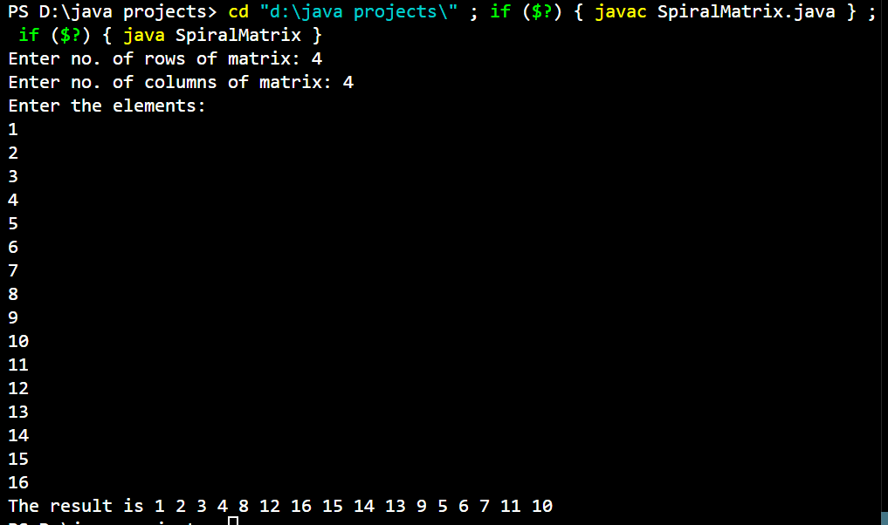

Time Complexity: O(m*n)

Space Complexity: O(1)

1. Check if given Parentheses expression is balanced or not

Given a string str of length N, consisting of ‘(’ and ‘)’ only, the task is to check whether it is balanced or not.

Input: str = “((()))()()”

Output: Balanced

Input: str = “())((())”

Output: Not Balanced

Solution:

import java.util.*;

public class BalancingParanthesis {

    public static void main(String[] args) {

        Scanner sc=new Scanner(System.in);

        System.out.print("Enter the string: ");

        String s=sc.nextLine();

        sc.close();

        Boolean res=false;

        Stack<Character> stack=new Stack<>();

        for (int i=0;i<s.length();i++){

            char c= s.charAt(i);

            if (stack.empty()) stack.push(c);

            else if (c=='(' || c=='[' || c=='{') stack.push(c);

            else if ((c==')' && stack.peek()=='(') || (c==']' && stack.peek()=='[') || (c=='}' && stack.peek()=='{')){

                stack.pop();

            }

            else break;

        }

        if (stack.empty()) res= true;

        if (res) System.out.println("The string is Balanced");

        else System.out.println("The string is Not Balanced");

    }

}

Output:

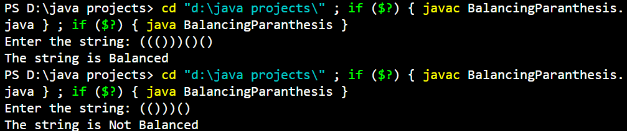

1. Check if two Strings are Anagrams of each other

Given two strings s1 and s2 consisting of lowercase characters, the task is to check whether the two given strings are anagrams of each other or not. An anagram of a string is another string that contains the same characters, only the order of characters can be different.

Input: s1 = “geeks” s2 = “kseeg”

Output: true

Explanation: Both the string have same characters with same frequency. So, they are anagrams.

Input: s1 = “allergy” s2 = “allergic”

Output: false

Explanation: Characters in both the strings are not same. s1 has extra character „y‟ and s2 has extra characters „i‟ and „c‟, so they are not anagrams.

Input: s1 = “g”, s2 = “g”

Output: true

Explanation: Characters in both the strings are same, so they are anagrams.

Solution:

import java.util.Arrays;

import java.util.Scanner;

public class ValidAnagrams {

    public static void main(String[] args) {

        Scanner sc=new Scanner(System.in);

        System.out.print("Enter the string 1: ");

        String s1=sc.nextLine();

        System.out.print("Enter the string 2: ");

        String s2=sc.nextLine();

        sc.close();

        System.out.println(Anagram(s1,s2));

    }

    static Boolean Anagram(String s1,String s2){

        if(s1.length()!=s2.length()) return false;

        char[] sArray = s1.toCharArray();

        char[] tArray = s2.toCharArray();

        Arrays.sort(sArray);

        Arrays.sort(tArray);

        return Arrays.equals(sArray, tArray);

    }

}

Output:

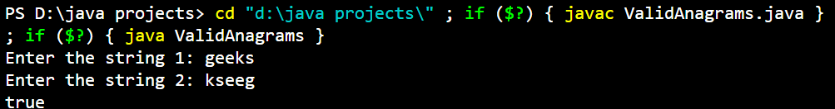

Time Complexity: O(nlogn)

Space Complexity: O(n)

1. Longest Palindromic Substring

Given a string str, the task is to find the longest substring which is a palindrome. If there are multiple answers, then return the first appearing substring.

Input: str = “forgeeksskeegfor”

Output: “geeksskeeg”

Explanation: There are several possible palindromic substrings like “kssk”, “ss”, “eeksskee” etc. But the substring “geeksskeeg” is the longest among all.

Input: str = “Geeks”

Output: “ee”

Input: str = “abc”

Output: “a”

Input: str = “”

Output: “”

Solution:

import java.util.Scanner;

public class LongestPalindrome {

    public static void main(String[] args) {

        Scanner sc=new Scanner(System.in);

        System.out.print("Enter the string: ");

        String s=sc.nextLine();

        sc.close();

        if (s.length() <= 1) {

            System.out.println(s);

        }

        else{

            String maxStr = s.substring(0, 1);

            for (int i = 0; i < s.length() - 1; i++) {

                String odd = expandFromCenter(s, i, i);

                String even = expandFromCenter(s, i, i + 1);

                if (odd.length() > maxStr.length()) {

                    maxStr = odd;

                }

                if (even.length() > maxStr.length()) {

                    maxStr = even;

                }

            }

            System.out.println(maxStr);

        }

    }

    static String expandFromCenter(String s, int left,int right){

        while (left >= 0 && right < s.length() && s.charAt(left) == s.charAt(right)) {

            left--;

            right++;

        }

        return s.substring(left + 1, right);

    }

}

Output:

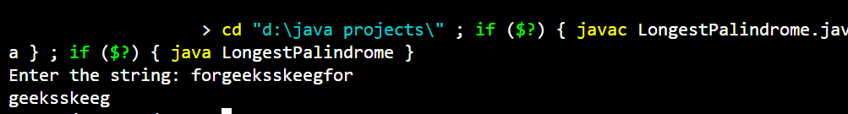

Time Complexity: O(n^2)

Space Complexity: O(1)

1. Longest Common Prefix using Sorting

Given an array of strings arr[]. The task is to return the longest common prefix among each and every strings present in the array. If there‟s no prefix common in all the strings, return “-1”.

Input: arr[] = [“geeksforgeeks”, “geeks”, “geek”, “geezer”]

Output: gee

Explanation: “gee” is the longest common prefix in all the given strings.

Input: arr[] = [“hello”, “world”]

Output: -1

Explanation: There‟s no common prefix in the given strings

Solution:

import java.util.*;

public class CommonPrefix {

    public static void main(String[] args) {

        Scanner sc=new Scanner(System.in);

        System.out.print("Enter the size of array: ");

        int n=sc.nextInt();

        sc.nextLine();

        System.out.println("Enter the array elements: ");

        String[] strs=new String[n];

        for(int i=0;i<n;i++) strs[i]=sc.nextLine();

        //System.out.println(strs);

        sc.close();

        StringBuilder ans = new StringBuilder();

        Arrays.sort(strs);

        String first = strs[0];

        String last = strs[n-1];

        for (int i=0; i<Math.min(first.length(), last.length()); i++) {

            if (first.charAt(i) != last.charAt(i)) {

                break;

            }

            ans.append(first.charAt(i));

        }

        if(ans.length()==0) System.out.println(-1);

        else System.out.println("Common prefix: "+ans.toString());

    }

}

Output:

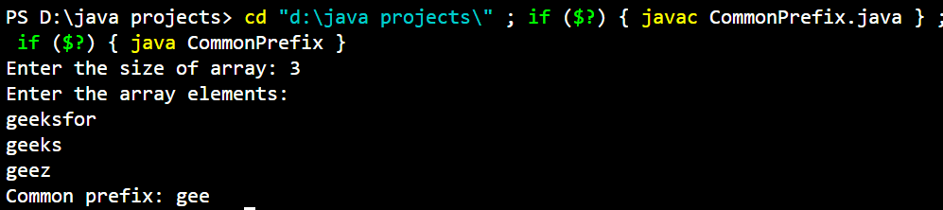

Time Complexity: O(nLogn)

Space Complexity:O(n)

1. Delete middle element of a stack

Given a stack with push(), pop(), and empty() operations, The task is to delete the middle element of it without using any additional data structure.

Input : Stack[] = [1, 2, 3, 4, 5]

Output : Stack[] = [1, 2, 4, 5]

Input : Stack[] = [1, 2, 3, 4, 5, 6]

Output : Stack[] = [1, 2, 4, 5, 6]

Solution:

import java.util.Stack;

public class DeleteMiddleElement {

    static void deleteMiddle(Stack<Integer> stack, int current, int size) {

        if (current == size / 2) {

            stack.pop(); // Remove the middle element

            return;

        }

        int temp = stack.pop();

        deleteMiddle(stack, current + 1, size);

        stack.push(temp);

    }

    static void deleteMiddleElement(Stack<Integer> stack) {

        if (stack.isEmpty()) return;

        int size = stack.size();

        deleteMiddle(stack, 0, size);

    }

    public static void main(String[] args) {

        Stack<Integer> stack = new Stack<>();

        stack.push(1);

        stack.push(2);

        stack.push(3);

        stack.push(4);

        stack.push(5);

        System.out.println("Original Stack: " + stack);

        deleteMiddleElement(stack);

        System.out.println("Stack after deleting middle element: " + stack);

        Stack<Integer> stack2 = new Stack<>();

        stack2.push(1);

        stack2.push(2);

        stack2.push(3);

        stack2.push(4);

        stack2.push(5);

        stack2.push(6);

        System.out.println("Original Stack: " + stack2);

        deleteMiddleElement(stack2);

        System.out.println("Stack after deleting middle element: " + stack2);

    }

}

Output:

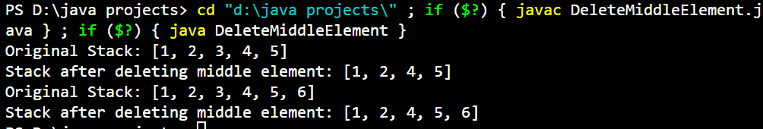

Time Complexity: O(n)

Space Complexity: O(n)

1. Next Greater Element (NGE) for every element in given Array

Given an array, print the Next Greater Element (NGE) for every element.

Note: The Next greater Element for an element x is the first greater element on the right side of x

in the array. Elements for which no greater element exist, consider the next greater element as -1.

Input: arr[] = [ 4 , 5 , 2 , 25 ]

Output: 4 –> 5

5 –> 25

2 –> 25

25 –> -1

Explanation: Except 25 every element has an element greater than them present on the right side

Solution:

import java.util.Scanner;

import java.util.Stack;

public class NextGreaterElement {

    public static void main(String[] args) {

        Scanner sc=new Scanner(System.in);

        System.out.print("Enter the size of array: ");

        int n=sc.nextInt();

        System.out.println("Enter the array elements: ");

        int[] arr=new int[n];

        for(int i=0;i<n;i++) arr[i]=sc.nextInt();

        sc.close();

        int[] nge=new int[n];

        Stack<Integer> stack=new Stack<>();

        for(int i=n-1;i>=0;i--){

            while(!stack.empty() && stack.peek()<=arr[i]){

                stack.pop();

            }

            if(stack.empty()){

                nge[i]=-1;

            }else{

                nge[i]=stack.peek();

            }

            stack.push(arr[i]);

        }

        System.out.println("Result is: ");

        for (int i = 0; i < n; i++) {

            System.out.println(arr[i]+" --> "+nge[i]);

        }

    }

}

Output:

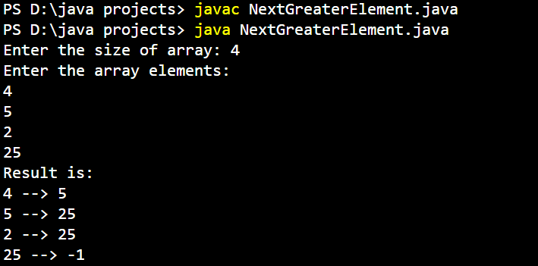

Time Complexity: O(n)

Space Complexity:O(n)

1. Print Right View of a Binary Tree

Given a Binary Tree, the task is to print the Right view of it. The right view of a Binary Tree is a set of rightmost nodes for every level.

Solution:

import java.util.*;

class BinaryTree {

static class Node {

int data;

Node left, right;

Node(int item) {

data = item;

left = right = null;

}

}

public static void printRightView(Node root) {

if (root == null) {

return;

}

Queue<Node> queue = new LinkedList<>();

queue.add(root);

while (!queue.isEmpty()) {

int nodeCount = queue.size();

for (int i = 1; i <= nodeCount; i++) {

Node currentNode = queue.poll();

if (i == nodeCount) {

System.out.print(currentNode.data + " ");

}

if (currentNode.left != null) {

queue.add(currentNode.left);

}

if (currentNode.right != null) {

queue.add(currentNode.right);

}

}

}

}

public static void main(String[] args) {

Node root = new Node(1);

root.left = new Node(2);

root.right = new Node(3);

root.left.right = new Node(5);

root.right.right = new Node(4);

printRightView(root);

}

}

Output:



Time Complexity: O(n)

Space Complexity:O(n)

1. Maximum Depth or Height of Binary Tree

Given a binary tree, the task is to find the maximum depth or height of the tree. The height of the

tree is the number of vertices in the tree from the root to the deepest node.

Solution:

class BinaryTree {

static class Node {

int data;

Node left, right;

Node(int item) {

data = item;

left = right = null;

}

}

public static int maxDepth(Node root) {

if (root == null) {

return 0;

}

int leftHeight = maxDepth(root.left);

int rightHeight = maxDepth(root.right);

return Math.max(leftHeight, rightHeight) + 1;

}

public static void main(String[] args) {

Node root = new Node(1);

root.left = new Node(2);

root.right = new Node(3);

root.left.left = new Node(4);

root.left.right = new Node(5);

root.left.left.left = new Node(6);

System.out.println("Maximum Depth of Binary Tree: " + maxDepth(root));

}

}

Output:



Time Complexity: O(n)

Space Complexity:O(logn)